CS6P05NI

19030695 Abhishek Rokaya

Final year project

Software Requirement Specification (SRS)

Dental Appointment System

Table of Contents

1. Introduction 1

1.1 Purpose 1

1.2 Intended Audience 1

1.3 Project Scope 2

2. Overall Description 3

2.1 System Perspective 3

2.2 System Features 5

2.3 User Class and Characteristics 6

2.4 Operating Environment 7

2.5 Design and implementation constraints 7

2.6 Assumptions and Dependencies 8

3. Functional Requirement 9

3.1 Login Feature 9

3.2 Register Feature 10

3.3 Booking an appointment and manage appointment 11

3.4 View Report 12

3.5 View Doctor 13

3.6 View Services 14

3.7 Manage Profile 15

4. External Interface Requirement 16

4.1 User Interfaces 16

4.2 Hardware Interfaces 21

4.3 Software Interfaces 21

4.4 Communication Interfaces 21

5. Non-Functional Requirements 22

5.1 Performance Requirements 22

5.2 Safety Requirements 22

5.3 Other Software Quality Attributes 23

**List of Figures**

Figure 1: System Perspective Diagram 3

Figure 2: Overall Use Case of the System 4

Figure 3: UI of Home Page 1 16

Figure 4: UI of Home Page 2 17

Figure 5: UI of Home Page 3 17

Figure 6: UI of Home Page 4 18

Figure 7: UI of Home Page 5 18

Figure 8: UI of Home Page 6 19

Figure 9: UI of Home Page 7 19

Figure 10: UI of Home Page 8 20

Figure 11: UI of Home Page 9 20

**List of Tables**

Table 1: Functional Requirement 1 9

Table 2: Functional Requirement 2 10

Table 3: Functional Requirement 3 11

Table 4: Functional Requirement 4 12

Table 5: Functional Requirement 5 13

Table 6: Functional Requirement 6 14

Table 7: Functional Requirement 7 15

Table 8: Performance Requirement 22

Table 9: Safety Requirement 22

Table 10: Other Software Quality Attributes 23

# 1. Introduction

**Project**: Dental Appointment System

**Category**: Web Application

## 1.1 Purpose

The primary purpose of this document is to provide a full description of the Dental Appointment System. It will explain the system's goal and characteristics, as well as the system's interfaces, what the system will perform, and the limitations under which it must operate. It provides a thorough explanation of the system's objectives, functionality, and user interface. It outlines how the application (system) will operate. This paper is designed for both system users and system developers.

## 1.2 Intended Audience

The intended audience for this system is the general public. Everyone has their dental needs that to be treated or cleaned. But not everyone has the time to go to the clinic and wait in line for hours. So, this system in intended for those people who do not wish to wait for hours for their check-up rather be more convenient and visit the clinic when they have the appointment time,

The SRS (Software requirement specification) is intended for:

* Client/User
* Developer
* Tester

## 1.3 Project Scope

The primary goal of this system is to manage users' appointments and to build a user-friendly application for booking appointments. This program assists users in connecting to a database server and logging into the system. Above all, we believe in providing excellent service at a reasonable cost. This application will help to schedule an appointment and manage the work efficiently It is a booking system that the user uses to schedule an appointment. The user can also view the doctors and services available along with the costs of services and the details of the doctors. Furthermore, users can view their report after their visit to the clinic. This helps avoid the loss of report that will be useful for the next meeting. This application is intended for a particular clinic only i.e. Phulchowki Dental Clinic.

The terms present in the documentations are:

* Admin: The person who is responsible for managing the whole system.
* User: A person who is using the application with limited privilege.
* Database: A server for the storing information of this system.

# 2. Overall Description

## 2.1 System Perspective

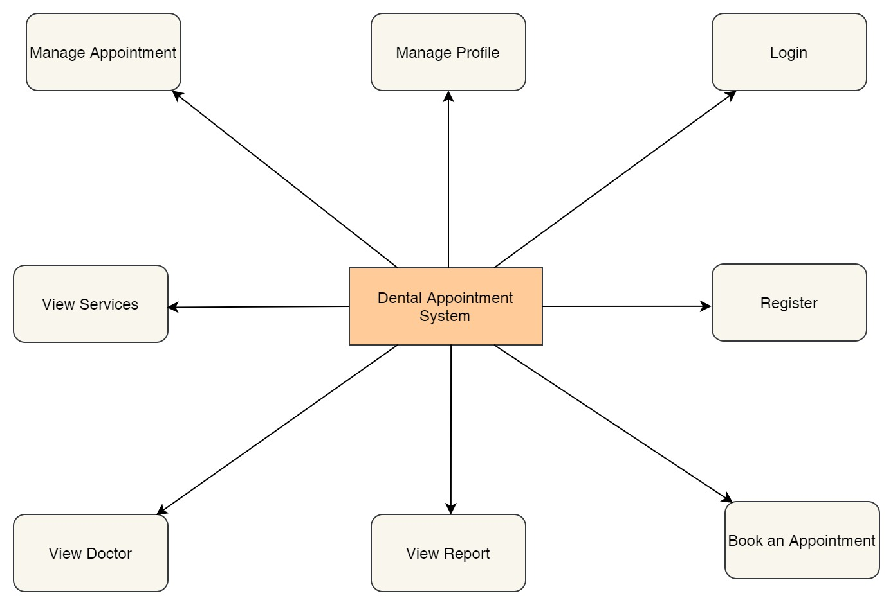

Figure 1: System Perspective Diagram

The features of the web based application are as mentioned below:

SP1: Register

SP2: Login

SP3: Book an appointment

SP4: View Report

SP5: View Doctor

SP6: View Services

SP7: Manage Appointment

SP8: Manage Profile

Use Case of the Overall System

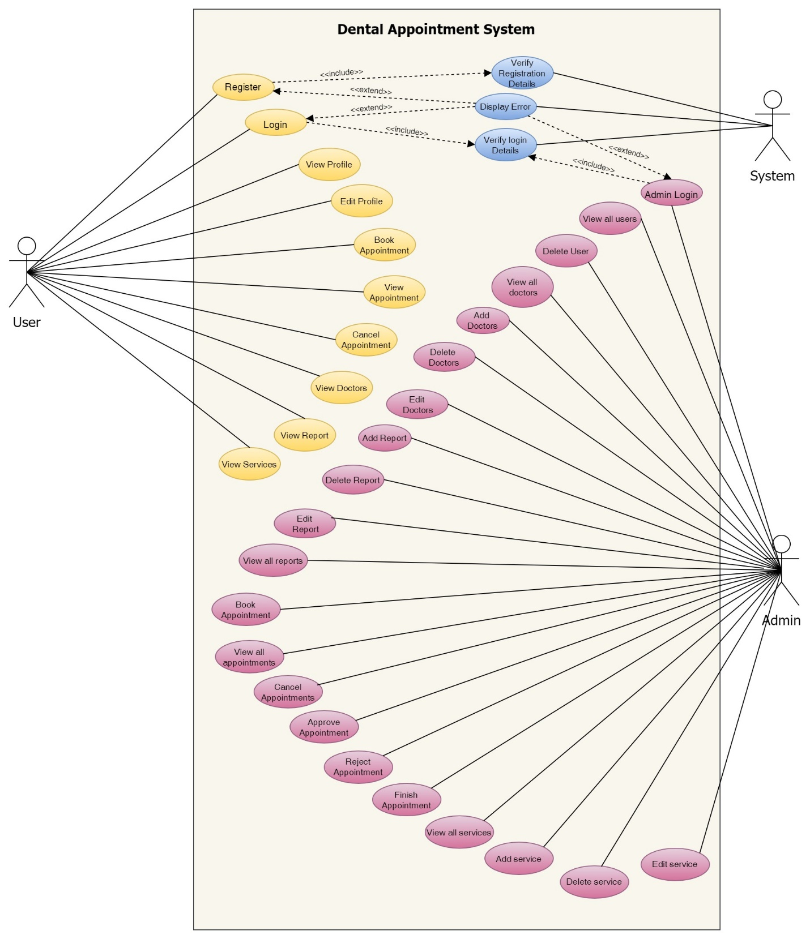

Figure 2: Overall Use Case of the System

## 2.2 System Features

**SP1: Register**

**Description:** New users who have not yet been registered to the system registers into it using the web browser. The registration details entered by the user is then verified by the system.

**SP2: Login**

**Description:** Registered Users can proceed to login to the system to use the features using the web browser. The login details entered by the customer is then verified by the system.

**SP3: Book an Appointment**

**Description:** Users can book an appointment for their dental requirements. The appointment is then reviewed by the admin.

**SP4: View Report**

**Description:** Users can view the report for their appointment only after it has been finished.

**SP5: View Doctor**

**Description:** Users can view the list of doctors available in the clinic along with their description and select the one they want to book an appointment with.

**SP6: View Services**

**Description:** Users can view the list of services available in the clinic along with the cost and description of it.

**SP7: Manage Appointment**

**Description:** Users can view the list of their appointments and cancel their pending as well confirmed appointment if the need arises to.

**SP8: Manage Profile**

**Description:** Users can view their profile and edit their details that they previously entered while registering. However, they cannot change their username.

## 2.3 User Class and Characteristics

The following are the classes for users who will be using the Dental Appointment System application with their roles:

**UC1: Patient User**

**UC1.1**: Book an appointment for their dental requirements

**UC1.2**: Browse doctors available in the clinic

**UC1.3**: View services available in the clinic

**UC1.4**: Manage their appointment

**UC1.5**: Manage their profile

**UC1.6**: View the reports of their appointment visit

**UC2: Admin User**

**UC2.1**: Manage appointments booked by the patient users like approving, rejecting, finishing and cancelling the appointments of the users.

**UC2.2**: Manage the reports of the user's appointments like adding, updating and deleting.

**UC2.3**: Manage the doctors in the clinic like adding new doctors, updating and deleting the existing ones if the need arises.

**UC2.4**: Manage the services in the clinic like adding new services, updating and deleting the existing ones if the need arises.

**UC2.5**: Manage users and deleting them if needed.

**UC3: Client**

**UC3.1**: Requirement analysis and finalization

**UC3.2**: Check whether the requirements are met or not at the time of delivery

**UC3.3**: Provide funding, resources and further information if needed

**UC4: Developer**

**UC4.1**: Check for errors and fix the bugs

**UC4.2**: Add additional features

**UC4.3**: Provide progress to the client

**UC4.4**: Manage the databases

## 2.4 Operating Environment

**OE1:** Currently the dental appointment system web application is available in any web browser like Google Chrome, Microsoft Edge, Mozilla Firefox, etc. In the near future, the application will also run on other platforms such as Android and iOS.

## 2.5 Design and implementation constraints

**CO1:** Only registered users can book the appointment.

**CO2:** Reports can only be made of appointments that are marked as finished by the admin.

**CO3:** User can only view their appointment, report and profile.

**CO4:** User can view all the doctors and services.

**CO5:** User cannot access the admin's panel.

**CO6:** User can only cancel their pending and confirmed appointments.

**CO7:** Only admin can approve, reject and finish the user's appointments.

**CO8:** Only admin can manage the doctor, reports and services

**CO8:** The appointment can only be taken from 9am – 5pm any day of the week.

## 2.6 Assumptions and Dependencies

**AS1**: This application is target mainly for those who have to visit dental clinic for their dental check-ups.

**AS2**: The application will be connected with the database.

**AS3**: The documentation and reports of the system are only accessible to limited people like the client and developers.

**AS4**: The users can book any number of appointment they may like to. However, they may only choose one service at a time but can include other services at the same time by mentioning in the description.

# 3. Functional Requirement

## 3.1 Login Feature

|  |  |  |  |
| --- | --- | --- | --- |
| **Req.ID** | **Requirement Description** | **Priority** | **Complexity** |
| **FR1** | All users will be able to access the login page   |  |  | | --- | --- | | **System Requirement** | | | **SR1** | On opening the application, the user will be directed to the home/landing page. | | **SR2** | When the user click the ‘Login’ button, they will be directed to the login page | | **SR3** | The user needs to enter their login details i.e. username and password in order to log in to the application. If the credentials are correct, they will be redirected towards the user dashboard page. | | Most | High |

Table 1: Functional Requirement 1

## 3.2 Register Feature

|  |  |  |  |
| --- | --- | --- | --- |
| **Req.ID** | **Requirement Description** | **Priority** | **Complexity** |
| **FR2** | All users will be able to access the register page   |  |  | | --- | --- | | **System Requirement** | | | **SR4** | When the user click the ‘Register' button, they will be directed to the register page | | **SR5** | The user needs to fill the registration form. The details are then verified by the system and the user will be registered in to the system. The user can then log in using their username and password. | | Most | High |

Table 2: Functional Requirement 2

## 3.3 Booking an appointment and manage appointment

|  |  |  |  |
| --- | --- | --- | --- |
| **Req.ID** | **Requirement Description** | **Priority** | **Complexity** |
| **FR3** | All users who are registered and logged in will be able to use this feature.   |  |  | | --- | --- | | **System Requirement** | | | **SR6** | After logging in, the users will be directed to their dashboard page. | | **SR7** | When the user clicks the ‘Book Appointment’ button, they will be directed to the book appointment page. | | **SR8** | The user needs to fill the form and click submit. If the details are valid, the appointment is then viewed by admin for approval. | | Most | High |
| **FR4** | All users who have at least one appointment can use this feature.   |  |  | | --- | --- | | **System Requirement** | | | **SR9** | When the user clicks the ‘View Appointment’ button, they will be directed to the view appointment page. | | **SR10** | The user can cancel their pending or confirmed appointment by clicking the 'cancel' button. | | Most | High |

Table 3: Functional Requirement 3

## 3.4 View Report

|  |  |  |  |
| --- | --- | --- | --- |
| **Req.ID** | **Requirement Description** | **Priority** | **Complexity** |
| **FR5** | The user must have at least one appointment marked as finished to view the reports.   |  |  | | --- | --- | | **System Requirement** | | | **SR11** | After logging in, the users will be directed to their dashboard page. | | **SR12** | When the user clicks the ‘View Report’ button, they will be directed to the view report page. | | **SR13** | The user will be able to view the report details of the appointment that they have finished. The admin upload the report and the user can view it. | | Most | High |

Table 4: Functional Requirement 4

## 3.5 View Doctor

|  |  |  |  |
| --- | --- | --- | --- |
| **Req.ID** | **Requirement Description** | **Priority** | **Complexity** |
| **FR6** | The user must be registered and logged in to view this feature.   |  |  | | --- | --- | | **System Requirement** | | | **SR14** | After logging in, the users will be directed to their dashboard page. | | **SR15** | When the user clicks the ‘View Doctor' button, they will be directed to the view doctor page. | | **SR16** | The user will be able to view the doctors along with their details. | | Most | Normal |

Table 5: Functional Requirement 5

## 3.6 View Services

|  |  |  |  |
| --- | --- | --- | --- |
| **Req.ID** | **Requirement Description** | **Priority** | **Complexity** |
| **FR7** | The user must be registered and logged in to view this feature.   |  |  | | --- | --- | | **System Requirement** | | | **SR17** | After logging in, the users will be directed to their dashboard page. | | **SR18** | When the user clicks the ‘View Services' button, they will be directed to the view services page. | | **SR19** | The user will be able to view the services along with their details. | | Most | Normal |

Table 6: Functional Requirement 6

## 3.7 Manage Profile

|  |  |  |  |
| --- | --- | --- | --- |
| **Req.ID** | **Requirement Description** | **Priority** | **Complexity** |
| **FR8** | The user must be registered and logged in to view this feature.   |  |  | | --- | --- | | **System Requirement** | | | **SR20** | After logging in, the users will be directed to their dashboard page. | | **SR21** | When the user clicks the ‘View Profile' button, they will be directed to the view profile page. | | **SR22** | The user will be able to view their details. | | Most | Medium |
| **FR9** | The user must be registered and logged in to view this feature.   |  |  | | --- | --- | | **System Requirement** | | | **SR23** | When the user clicks the ‘Edit Profile' button, they will be directed to the view services page. | | **SR24** | When the user clicks the ‘View Profile' button, they will be directed to the edit profile page. | | **SR25** | The user will be able to update their details and if the details are valid, the details of the users will be updated. | | Most | High |

Table 7: Functional Requirement 7

# 4. External Interface Requirement

## 4.1 User Interfaces

The project's user interface will be intended to be clean and simple to use. Simple phrases will be used, and page titles will be assigned based on the objective of the page. The application will make use of appropriate colour schemes and fonts. Similarly, the photos in the program will be retained in order to deliver a relevant message to the users. User testing will be done on a regular basis to ensure maximum effort and happiness.

The home page was made as a one page website. The screenshot of the home page UI is shown below:

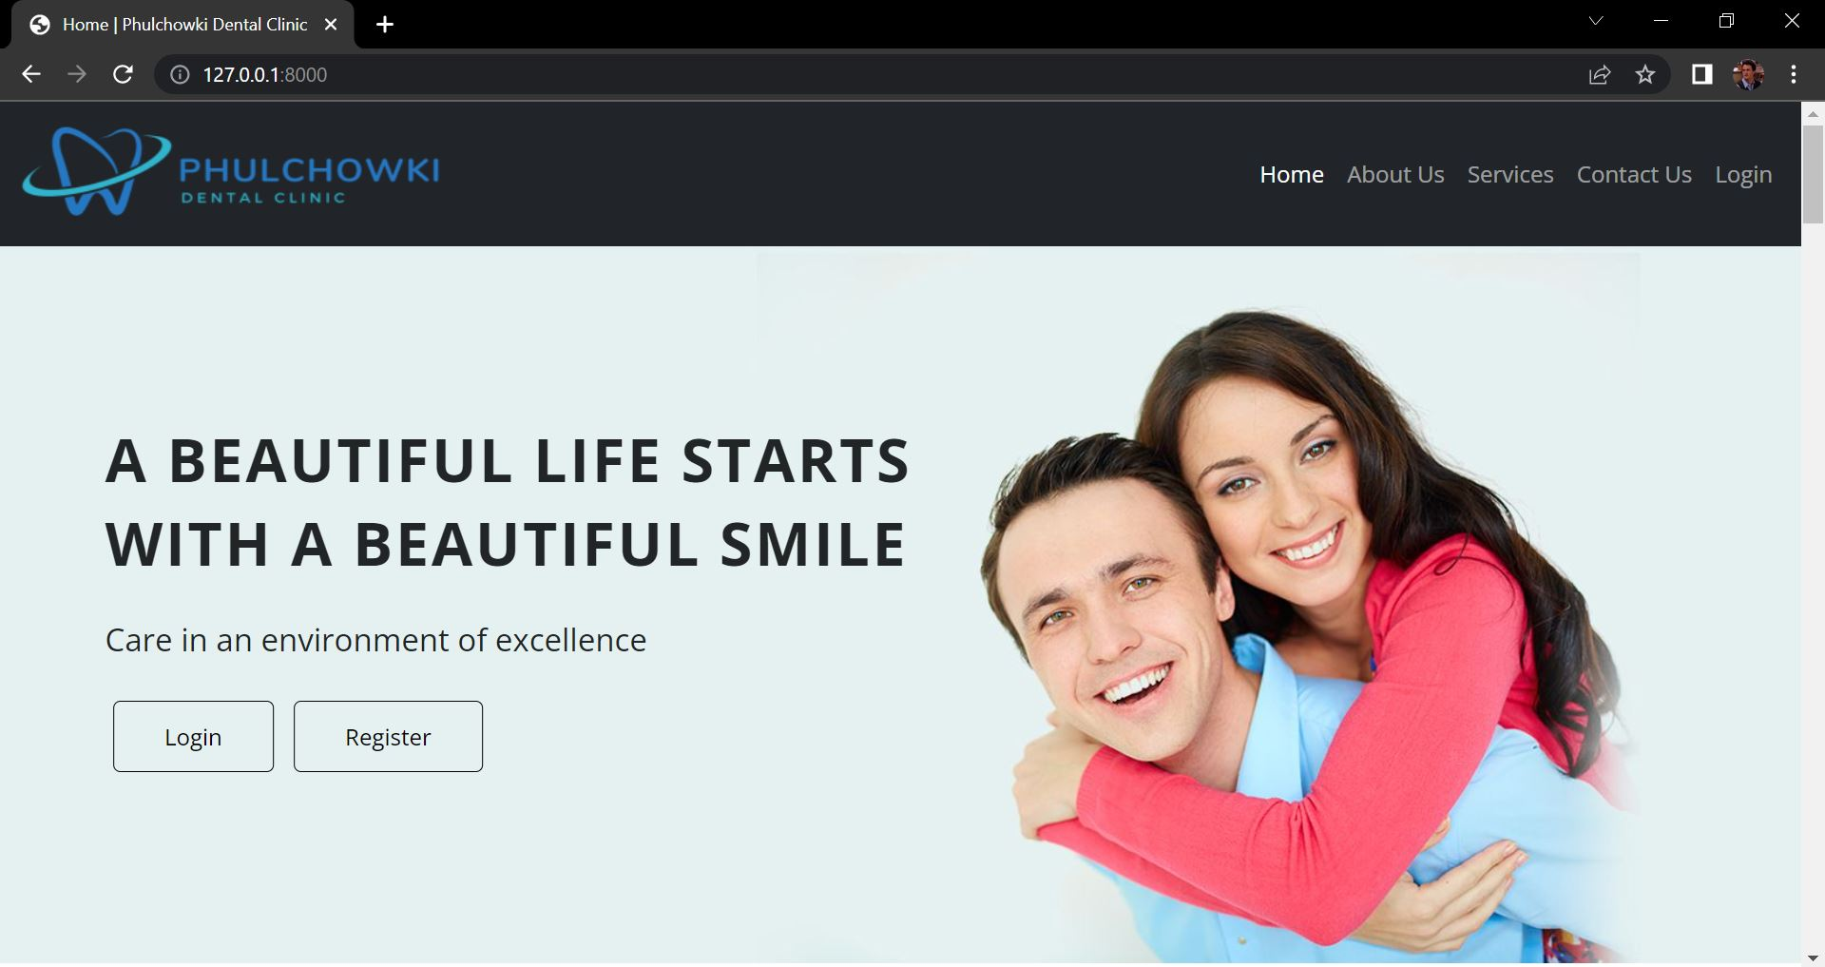

Figure 3: UI of Home Page 1

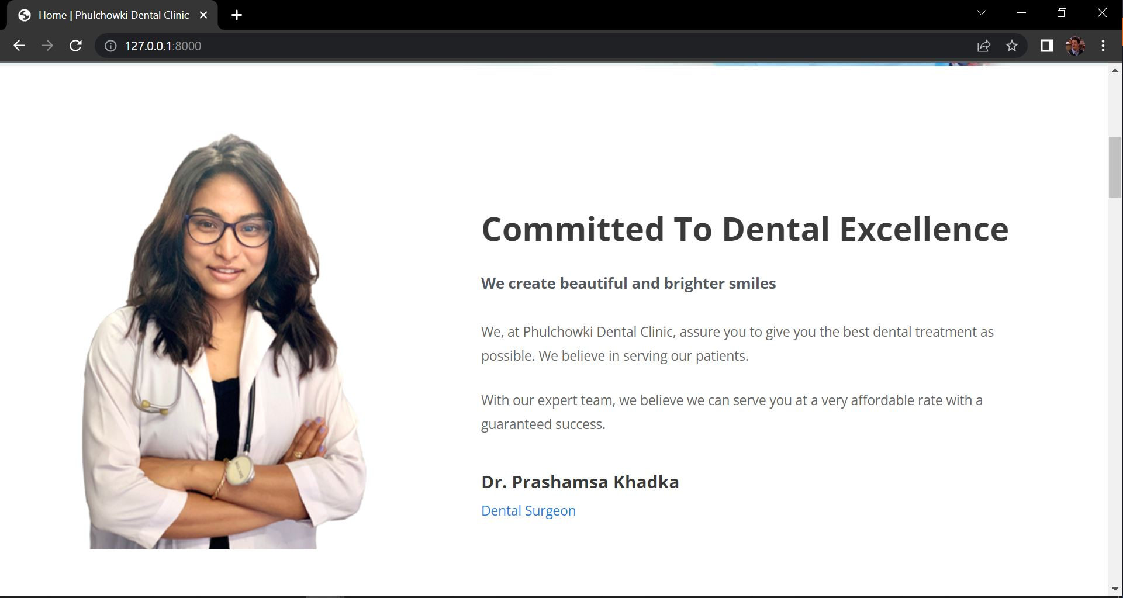

Figure 4: UI of Home Page 2

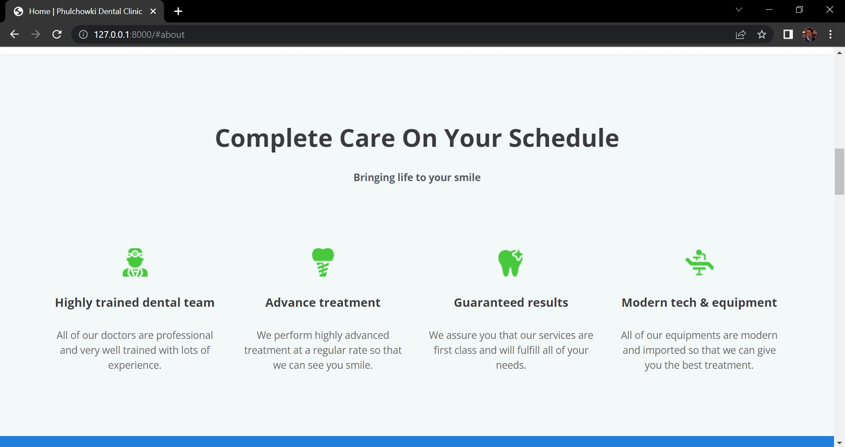

Figure 5: UI of Home Page 3

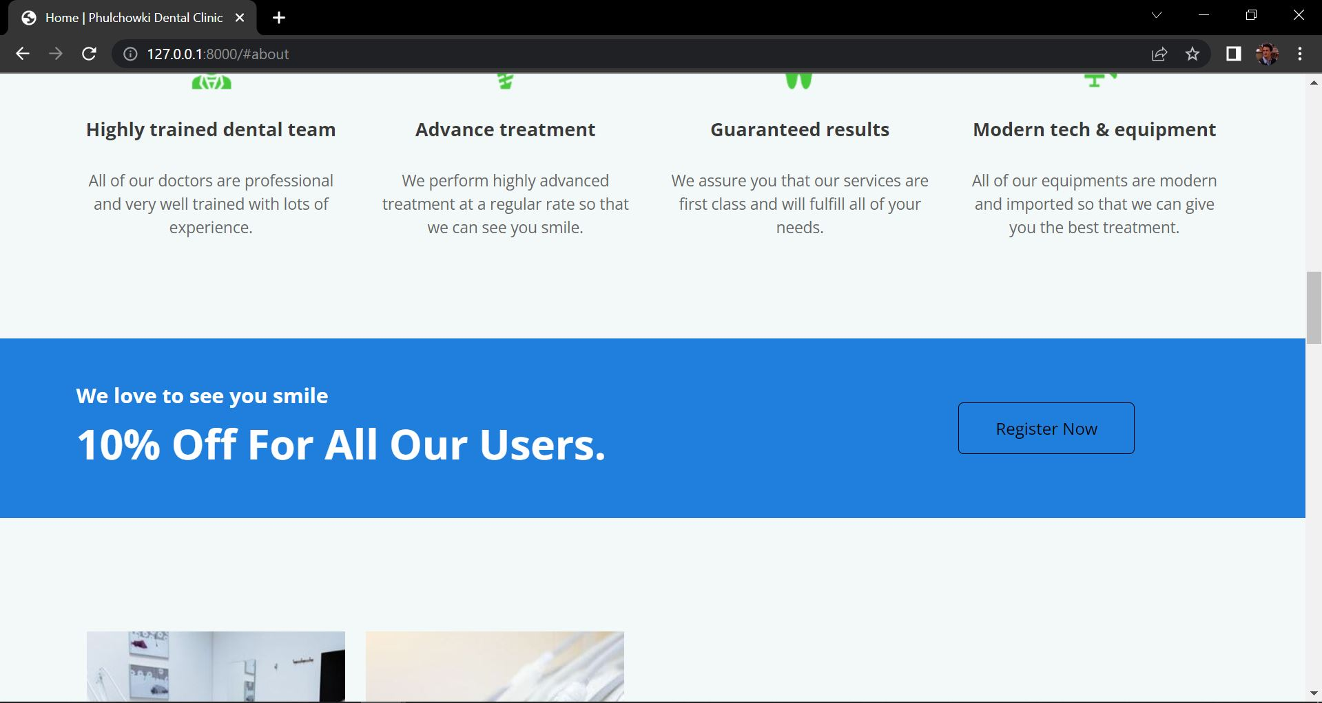

Figure 6: UI of Home Page 4

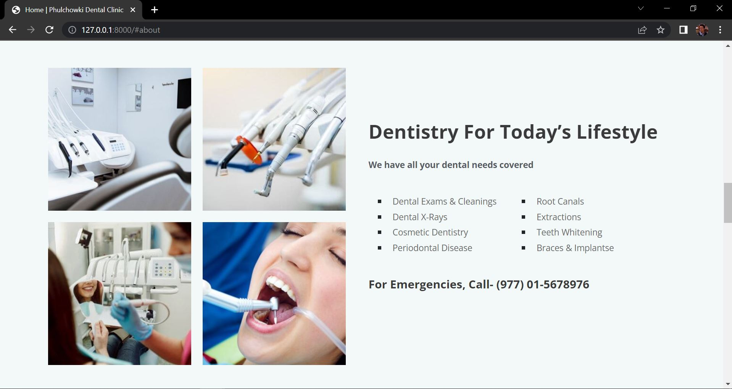

Figure 7: UI of Home Page 5

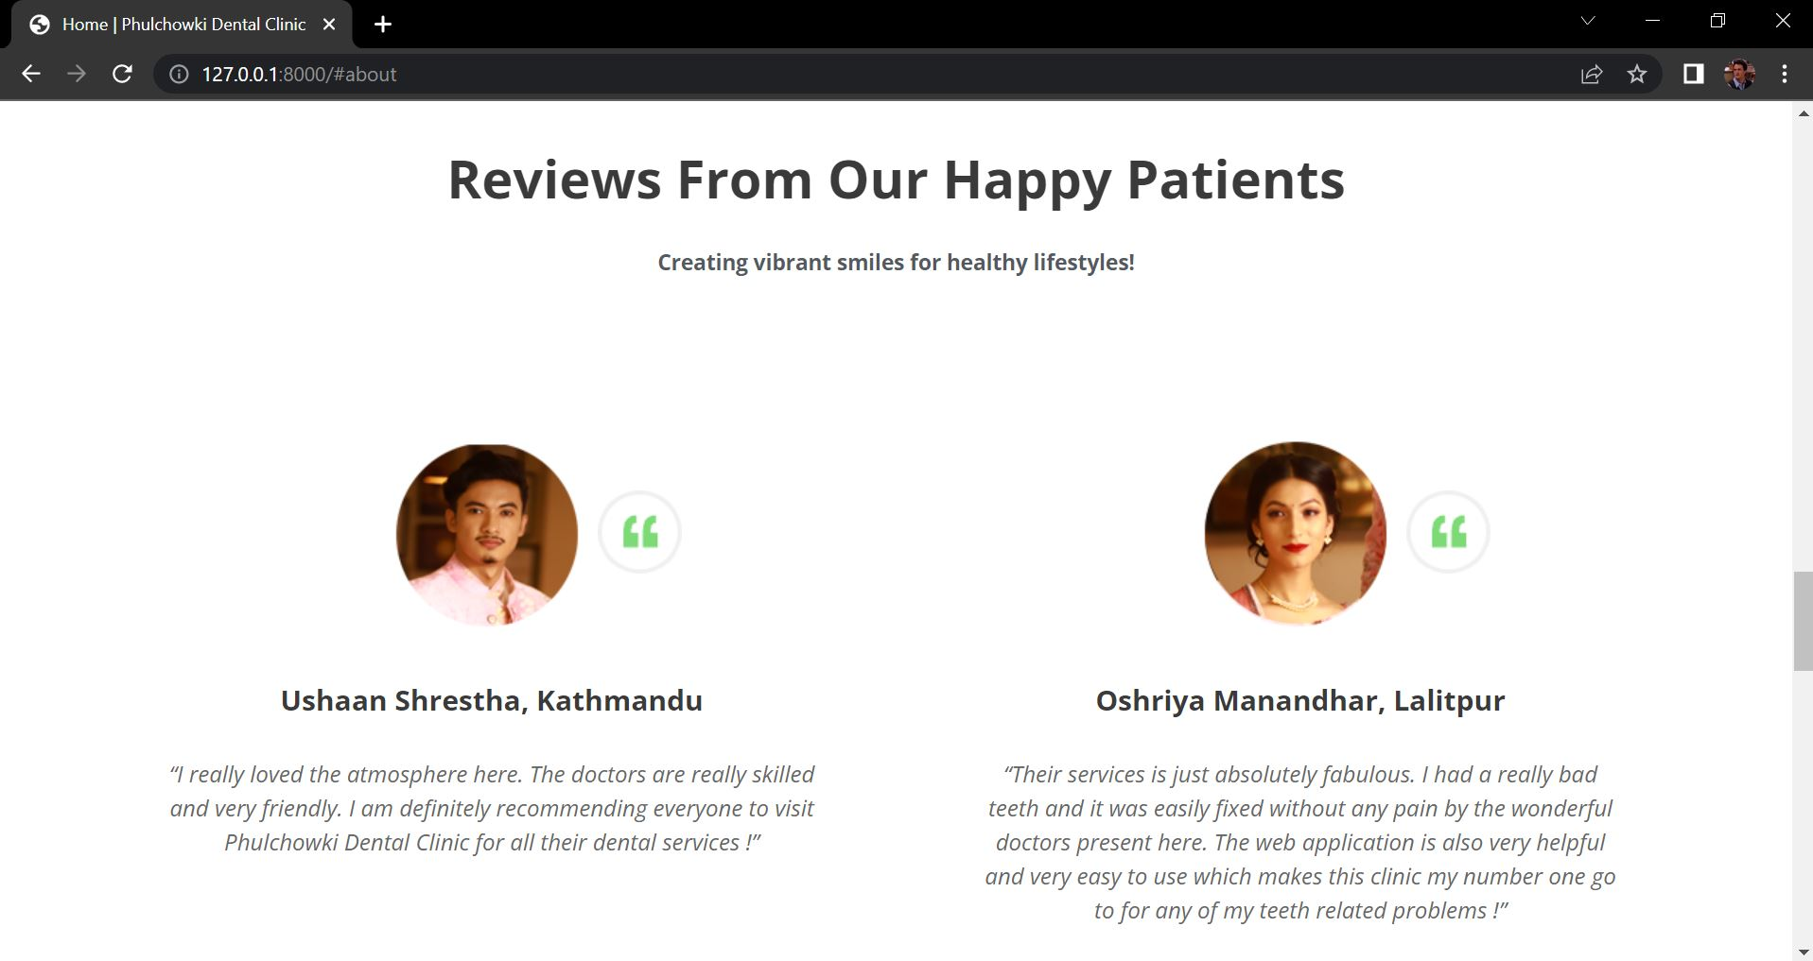

Figure 8: UI of Home Page 6

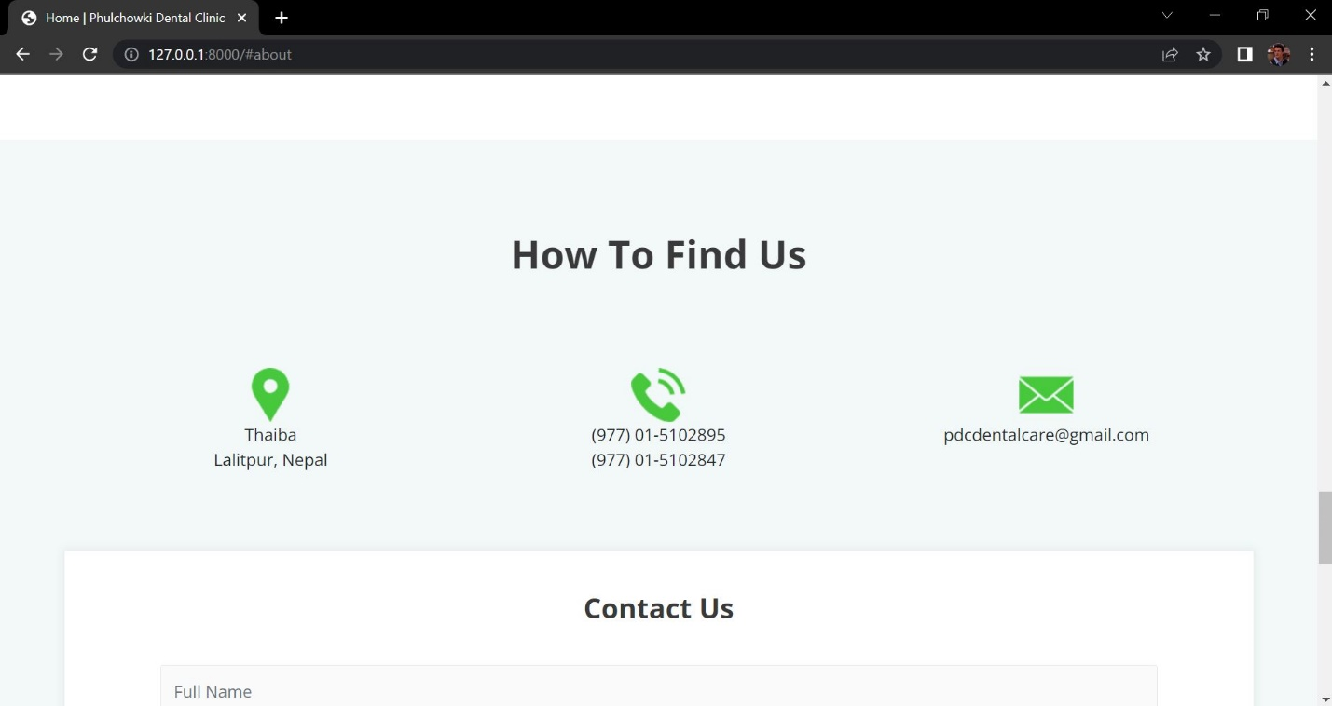

Figure 9: UI of Home Page 7

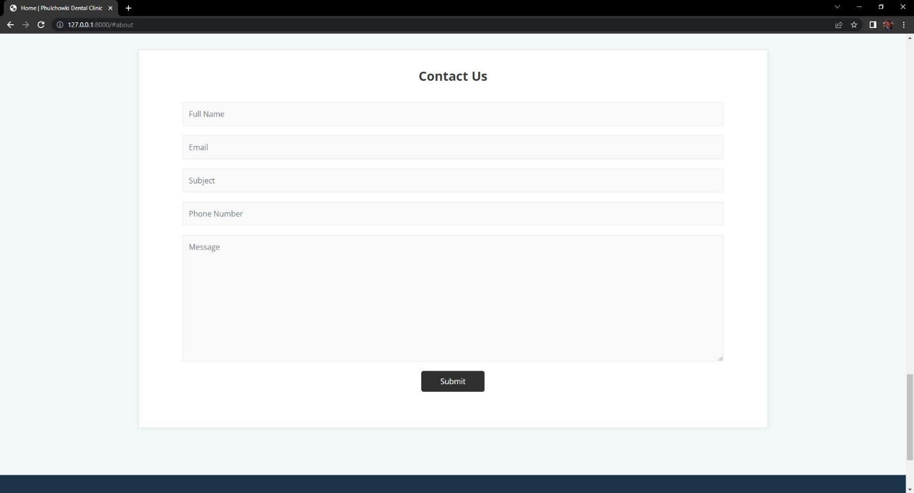

Figure 10: UI of Home Page 8

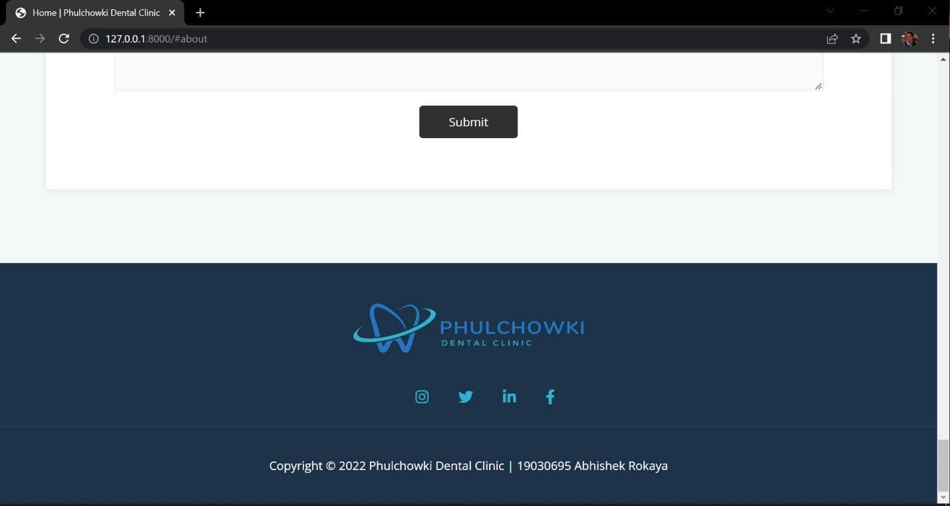

Figure 11: UI of Home Page 9

## 4.2 Hardware Interfaces

Since this is a web application, there are no such hardware requirements. This application can be executed on any functional machine with an internet connection.

## 4.3 Software Interfaces

The software interface for the application is as mentioned below:

* **Programming Language**: Python
* **Framework**: Django
* **IDE**: Visual Studio Code
* **Database**: SQLite3

## 4.4 Communication Interfaces

This system's communication interface will use the HTTP protocol for internet communication and the TCP/IP protocol suite for intranet communication.

# 5. Non-Functional Requirements

Non-functional requirements are those that are used to assess the application's quality. This section contains a comprehensive description of the application's non-functional needs.

## 5.1 Performance Requirements

|  |  |  |  |
| --- | --- | --- | --- |
| **Req. ID** | **Requirement Description** | **Priority** | **Complexity** |
| **PR1** | The system should be fast and easy to use. | Should | Medium |
| **PR2** | The system should be reliable meaning the function should work properly. | Should | Normal |
| **PR3** | The system should be user friendly. | Should | Normal |

Table 8: Performance Requirement

## 5.2 Safety Requirements

|  |  |  |  |
| --- | --- | --- | --- |
| **Req. ID** | **Requirement Description** | **Priority** | **Complexity** |
| **SR1** | The program shall not install any type of malware or spyware in the background without notifying the users. | Should | Medium |
| **SR2** | The system must keep track of the session to guarantee that the login and logout are secure. | Should | High |
| **SR3** | A user category must not have access to the profiles of other user categories, i.e. a user (patient) must not be able to access the admin panel. | Should | Medium |

Table 9: Safety Requirement

## 5.3 Other Software Quality Attributes

|  |  |  |  |
| --- | --- | --- | --- |
| **Req. ID** | **Requirement Description** | **Priority** | **Complexity** |
| **SQA1** | The system must be scalable, which means that it should be able to incorporate new features in the future. | Could | Medium |
| **SQA2** | All users must be able to quickly access the program. | Should | Normal |
| **SQA3** | The system must be user-friendly, and even non-technical users should be able to utilize it with ease. | Should | Normal |
| **SQA4** | The program must be interoperable, which means it must act consistently across browsers. | Could | Normal |

Table 10: Other Software Quality Attributes